# Experiment

Design an automated night lamp

**Circuit diagram:**

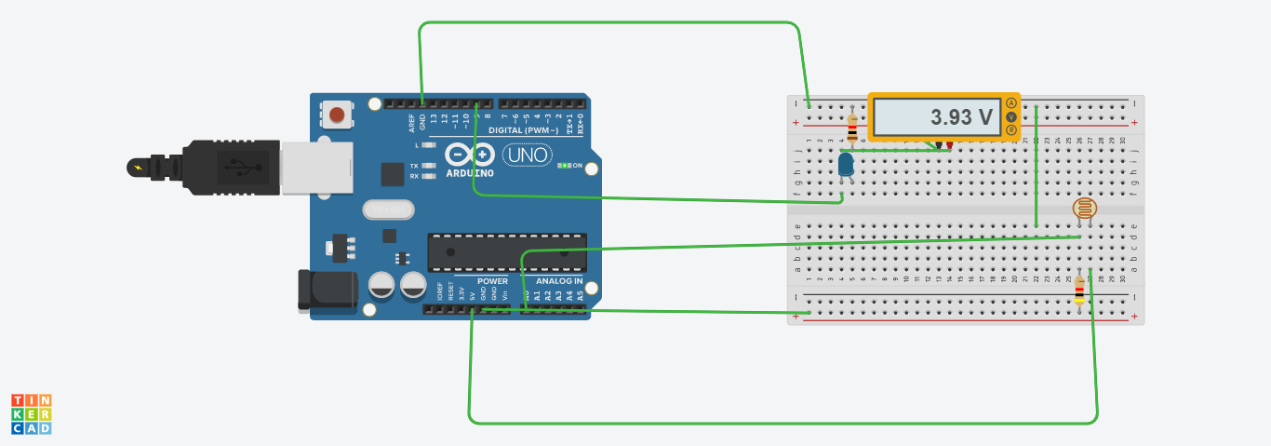

**Theory:**

# CONCEPT USED:

1. By using kirchoff’s voltage law
2. &
3. By using kirchoff’s current law
4. Photoradiation
5. Use of LDR(Light Dependent resistor)
6. Use of potentiometer

# LEARNING AND OBSERVATION'S:

1. Connections in Breadboard and wiring.
2. How to control arduino and its coding.
3. Use of multimeter for continuity.
4. Light sensor devices

**OBSERVATION:**

1. Sense of brightness and darkness
2. Relation between software and hardware.
3. Varation of voltage

# PROBLEMS & TROUBLESHOOTING:

1. To select the right port and type of arduino
2. To check the loose connections
3. To check the connections according to the codes
4. To check the continuity of the circuit
5. To check the flow of current in the circuit
6. Errors in code
7. Setting up right connections
8. Display in proper order
9. Pinmodes of devices

# PRECAUTIONS:

1. Do not connect arduino till the circuit is complete
2. Do not connect leds without a variable resistor

# OUTCOMES:

1. Making of automated light devices
2. By sensing light
3. Proper use of Arduino and breadboard